

PROJECT REPORT
on
Code Edit

Submitted by

Binayak Singh
Roll No.:201500195

Kaustubh Dubey
Roll No.:201500332

Saksham Gangwar
Roll No.:201500603

Shreyash Varshney
Roll No.:201500675

Kaustubh Yadav
Roll No.:201500333

Department of Computer Engineering & Applications
Institute of Engineering & Technology
GLA University
Mathura- 281406, U.P.

Declaration

I hereby declare that the work which is being presented in the Minor Project Report “Codeit”, in partial fulfillment of the requirements for Project is an authentic record of my own work carried under the supervision of Mr. Mayank Saxena, Technical Trainer, GLA University, Mathura.

Sign ______________________
Name of Candidate: Binayak Singh
University Roll No.:201500195

Sign ______________________
Name of Candidate: Kaustubh Dubey
University Roll No.: 201500332

Sign ______________________ Sign ______________________
Name of Candidate: Saksham Gangwar Name of Candidate: Shreyash Varshney
University Roll No:201500603 University Roll No:201500675

Sign ______________________
Name of Candidate: Yogesh Kumar
University Roll No.: 201500833

CERTIFICATION

This is to certify that the above statements made by the candidate are correct to the best of my/our knowledge and belief.

_____________________

Project Supervisor
Mr. Mayank Saxena
Technical Trainer

Date:

Table of Contents
- Introduction | 1
1.1 Overview and Objective……………………………. | 5
- Project / Training Design | 2
2.1 Use Case Diagram……………………….…………. | 6
- System Requirements | 3
3.1 Software Required…………………………………... | 7
3.2 Hardware Required…………...……………………... | 7
- Implementation and User Interface | 4
4.1 Source Code……………………................................. | 8-10
4.2 Components…………………….................................  4.3 Utils…………………………………………….......... | 10-12  12-14
5. Conclusion  6. References | 15  16

CHAPTER-1
INTRODUCTION
A code editor is a software application that allows developers to write, edit, and manage their code efficiently. It is an essential tool for developers, especially when working on complex projects, as it provides features that can help them write code more quickly, debug errors, and collaborate with team members.

In a project report, a code editor can be used to include code snippets and examples to support the project's findings and conclusions. It can also be used to provide a clear and concise demonstration of the project's functionality.

There are many different code editors available, each with its unique features and capabilities. Some popular code editors include Visual Studio Code, Sublime Text, Atom, and Notepad++. These editors provide a user-friendly interface, syntax highlighting, auto-completion, and debugging tools to enhance the developer's productivity.

In summary, a code editor is an essential tool for developers to create and manage their code efficiently. It can be used in a project report to provide clear and concise demonstrations of the project's functionality and support the project's findings and conclusions

CHAPTER-2
USE CASE DIAGRAM

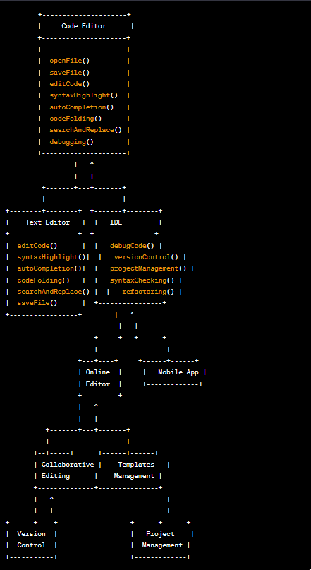

CHAPTER-3
SYSTEM REQUIREMENT

SOFTWARE AND HARDWARE REQUIREMENTS
- Windows 7+
- Processor Base Frequency of 1.8 GHz or higher
- 4 GB RAM or more
- 75 MB of available disk space or more
- Minimal screen resolution: 1366x768 pixels
- Camera and Mic (USB or Built in)

CHAPTER-4
IMPLEMENTATION

Codeit Project File Structure:
Here are the steps you will need to execute to build this project:
- First run the npx create-react-app in your terminal.
- Go to the package.json and include the needed dependencies in it.
- Now just run the npm –legacy-peer-dps to install all the required dependencies for the project.
- Now just go to the src file and work with App.js and index.js file.
- Then include the components folder to the src file where you will be including all the components of the project, so you just need to export it a use it at other location of the file.

Index.css
body {
margin: 0;
font-family: -apple-system, BlinkMacSystemFont, 'Segoe UI', 'Roboto',
'Oxygen', 'Ubuntu', 'Cantarell', 'Fira Sans', 'Droid Sans',
'Helvetica Neue', sans-serif;
-webkit-font-smoothing: antialiased;
-moz-osx-font-smoothing: grayscale;
background: #1c1e29;
}

Index.js

import React from 'react';
import ReactDOM from 'react-dom';
import './index.css';
import App from './App';
import reportWebVitals from './reportWebVitals';

ReactDOM.render(
<React.StrictMode>
<App />
</React.StrictMode>,
document.getElementById('root')
);

// If you want to start measuring performance in your app, pass a function
// to log results (for example: reportWebVitals(console.log))
// or send to an analytics endpoint. Learn more: https://bit.ly/CRA-vitals
reportWebVitals();

App.js

import './App.css';
import { BrowserRouter, Routes, Route } from 'react-router-dom';
import { Toaster } from 'react-hot-toast';
import Home from './pages/Home';
import EditorPage from './pages/EditorPage';

function App() {
return (
<>
<div>
<Toaster
position="top-right"
toastOptions={{
success: {
theme: {
primary: '#4aed88',
},
},
}}
></Toaster>
</div>
<BrowserRouter>
<Routes>
<Route path="/" element={<Home />}></Route>
<Route
path="/editor/:roomId"
element={<EditorPage />}
></Route>
</Routes>
</BrowserRouter>
</>
);
}

export default App;

Components

Client

import React from 'react';
import Avatar from 'react-avatar';
const Client = ({ username }) => {
return (
<div className="client">
<Avatar name={username} size={50} round="14px" />
<span className="userName">{username}</span>
</div>
);
};
export default Client;

Editor
import React, { useEffect, useRef } from 'react';
import Codemirror from 'codemirror';
import 'codemirror/lib/codemirror.css';
import 'codemirror/theme/dracula.css';
import 'codemirror/mode/javascript/javascript';
import 'codemirror/addon/edit/closetag';
import 'codemirror/addon/edit/closebrackets';
import ACTIONS from '../Actions';

const Editor = ({ socketRef, roomId, onCodeChange }) => {
const editorRef = useRef(null);
useEffect(() => {
async function init() {
editorRef.current = Codemirror.fromTextArea(
document.getElementById('realtimeEditor'),
{
mode: { name: 'javascript', json: true },
theme: 'dracula',
autoCloseTags: true,
autoCloseBrackets: true,
lineNumbers: true,
}
);
editorRef.current.on('change', (instance, changes) => {
const { origin } = changes;
const code = instance.getValue();
onCodeChange(code);
if (origin !== 'setValue') {
socketRef.current.emit(ACTIONS.CODE_CHANGE, {
roomId,
code,
});
}
});
}
init();
}, []);

useEffect(() => {
if (socketRef.current) {
socketRef.current.on(ACTIONS.CODE_CHANGE, ({ code }) => {
if (code !== null) {
editorRef.current.setValue(code);
}
});
}
return () => {
socketRef.current.off(ACTIONS.CODE_CHANGE);
};
}, [socketRef.current]);
return <textarea id="realtimeEditor"></textarea>;
};
export default Editor;
Utils
Socket.js -
import { io } from 'socket.io-client';
export const initSocket = async () => {
const options = {
'force new connection': true,
reconnectionAttempt: 'Infinity',
timeout: 10000,
transports: ['websocket'],
};
return io(process.env.REACT_APP_BACKEND_URL, options);
};

Action.js -
const ACTIONS = {
JOIN: 'join',
JOINED: 'joined',
DISCONNECTED: 'disconnected',
CODE_CHANGE: 'code-change',
SYNC_CODE: 'sync-code',
LEAVE: 'leave',
};
module.exports = ACTIONS;

CHAPTER-5
CONCLUSION
A code editor is an essential tool for programmers and developers. It can make a huge difference in productivity and efficiency by providing features such as syntax highlighting, auto-completion, and multiple cursors. There are many different types of code editors available, including text editors, IDEs, and online code editors, and each has its own unique features and benefits. Popular code editors today include Visual Studio Code, Sublime Text, and Atom, but there are many other options available depending on your specific needs and preferences

REFERENCES

- The Road to learn React by
- Robin Wieruch

- The Full Stack developer by
- Chris Northwood

- Modern Full Stack Development using React by
- Frank Zammetti

- Full stack Java Script by
- Azat Mardan

